Case 12-US-AL-Tukabatchee-Mississippian-Shell Gorget
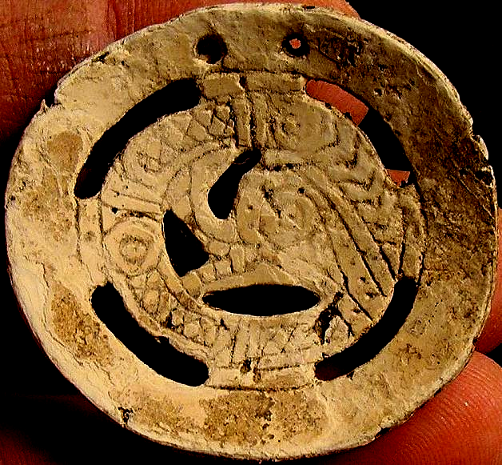
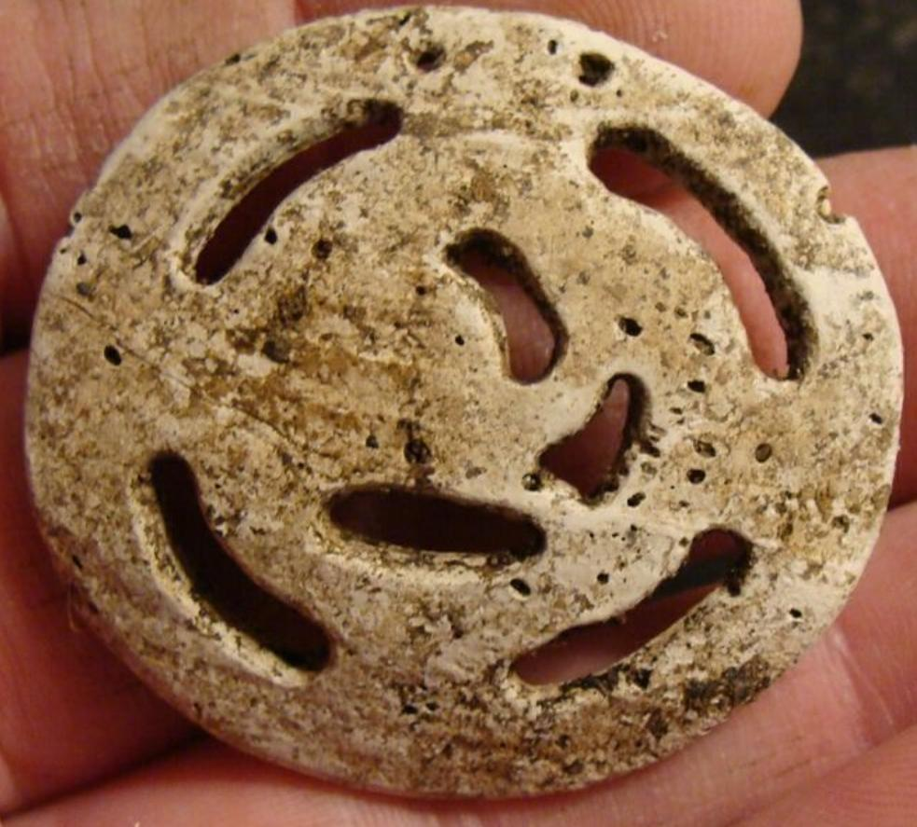
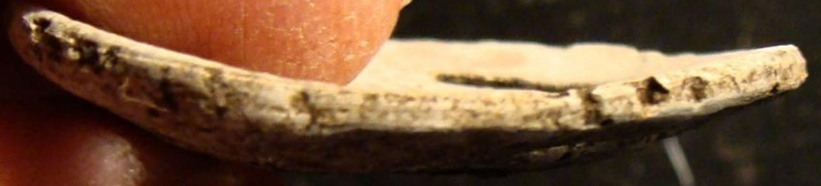
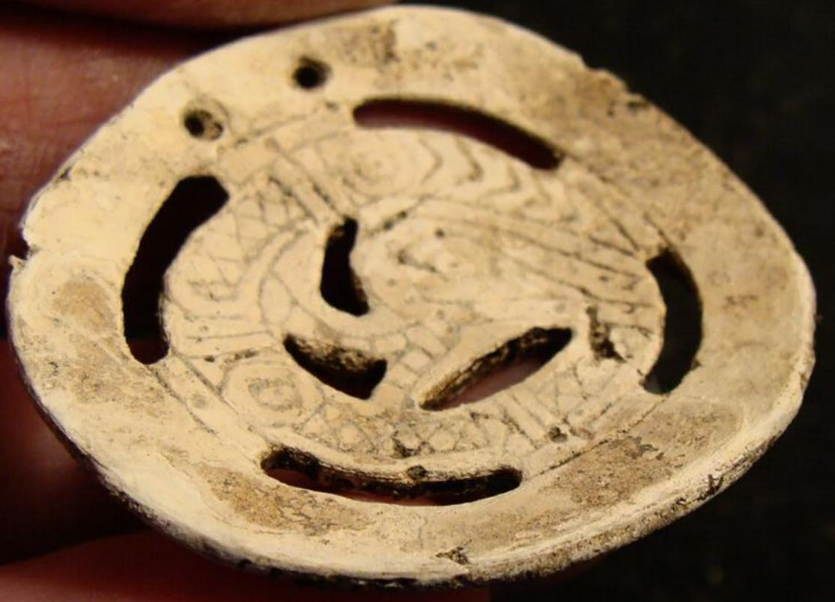

Case No.:
Accession Number:
Formal Label:
Display Description:
The Engraved Shell Gorget is one of the rarest artifacts made during the Southeastern Ceremonial Complex or SECC (also called the Southern Cult, the Mississippian Period, and the Temple Mound Period). The prehistoric natives began cutting and engraving pieces of conch and whelk shell as early as around AD 1000 in the current states of Oklahoma, Arkansas, Illinois and Tennessee. As the SECC advanced chronologically, it also moved geographically and eventually reached the Carolinas and Virginia around AD 1300-1400. This cultural manifestation was dominated by kingdoms composed of ordinary citizens and elite family rulers who required the lower class society members to raise their crops, hunt for their food, and also make religious/ceremonial/political prestige objects for the ruling family members. These objects included effigy pottery vessels, zoomorphic stone pipes and, of course, shell gorgets. Around AD 1450 the natives, living in the Appalachian Mountains from Georgia to Virginia, began engraving rattlesnakes on their shell gorgets. These mound building and gorget making societies continued to flourish in the mountainous region until the sixteenth century when the Spanish began to enter their lands. At that point the native cultures began to crumble.
The shell gorget was made by laboriously cutting a piece of the whorl of a marine gastropod shell, usually in a circular shape, and then drilling two holes along one edge so it could be suspended around a person’s neck. They were normally made in the size range of two to three inches in diameter but some extraordinary examples up to six inches across have been found. They are named gorget from the French word “gorge” which was a medieval piece of armor used to protect the wearer’s throat. Most Indian made shell gorgets were not engraved but some were embellished, usually on the concave surface, with various motifs.
LC Classification:
Date or Time Horizon:
Geographical Area:
Map:
GPS Coordinates:
Cultural Affiliation:
Medium: Conch shell
Dimensions: W 2 1/8 in H 1 1/2 in.
Weight:
Provenance: FROM THE COLLECTION OF DR. R.P. BURKE OF ELMORE COUNTY, ALABAMA.
FOUND AT TUKABACHEE SITE, ALABAMA, before 1950
Condition:
Discussion:
Tukabatchee or Tuckabutche) (Creek: Tokepahce ^{[1]}) is one of the four mother towns of the Muscogee Creek confederacy^{[2]} The pre-removal tribal town was located on the Tallapoosa River in the present-day state of Alabama.
The Creek Indians are more properly called the Muscogee, alternatively spelled Mvskoke. Creek oral tradition, recorded in the eighteenth century, told a legend of migration of one group of ancestral Creeks who established a colony at the Ocmulgee site near present Macon, Georgia. From that colony grew the pivotal towns of Cusseta and Coweta, in the period of A.D. 900-1000. The historic Creek Confederacy eventually was so widespread and influential that early-twentieth-century scientists speculated that Mississippian migrants had left their central Mississippi Valley homeland and journeyed onto the Macon Plateau, where they settled at Ocmulgee before beginning their regional expansion. Archaeologists corroborated that Ocmulgee Mounds was one of the ancestral Creek residences.
Subsequent archaeological investigations indicated that Creek Indians derived from prehistoric South Appalachian woodland cultures such as Western Lamar in the region of present Georgia and Alabama. While there were local variations, all were believed to share what is termed Mississippian culture. They resided in fortified towns, which had flat-topped pyramid temple mounds surrounding a central plaza. The Mississippian culture declined after A.D. 1400, which then became single-mound ceremonial centers among separate towns that were either related or allied. Perhaps half of them used the Mvskoke language, which was spoken along the Coosa and Tallapoosa watercourses, while those who lived along the Chattahoochee River perhaps spoke Hitchiti and Euchee. Although the people spoke different languages, they shared basic traits and beliefs with other Southeastern Indians. The arrival of Europeans accelerated the decline and had a devastating demographic impact upon the natives. From: http://digital.library.okstate.edu/encyclopedia/entries/C/CR006.html

References:
Eddings, Anna. Encyclopedia of Oklahoma History and Culture.

